Multimedia Web Design Homework
HTML EXERCISES (week 3)
Tables, Forms & Page Structure

Eda Selmani – Computer Engineering

Exercise 1: Add a projects table to your portfolio
In your index.html, after your skills section, add: (1) An <h2> heading: 'My Projects'. (2) A full HTML table with 3 columns: 'Project Name', 'Description', and 'Status'. (3) Include at least 3 rows of data (use real or made-up projects — be creative!). (4) Use <thead> and <tbody> properly. Bonus: Try using colspan on the header row to make a full-width title row that says 'Portfolio Projects' above the column headers.

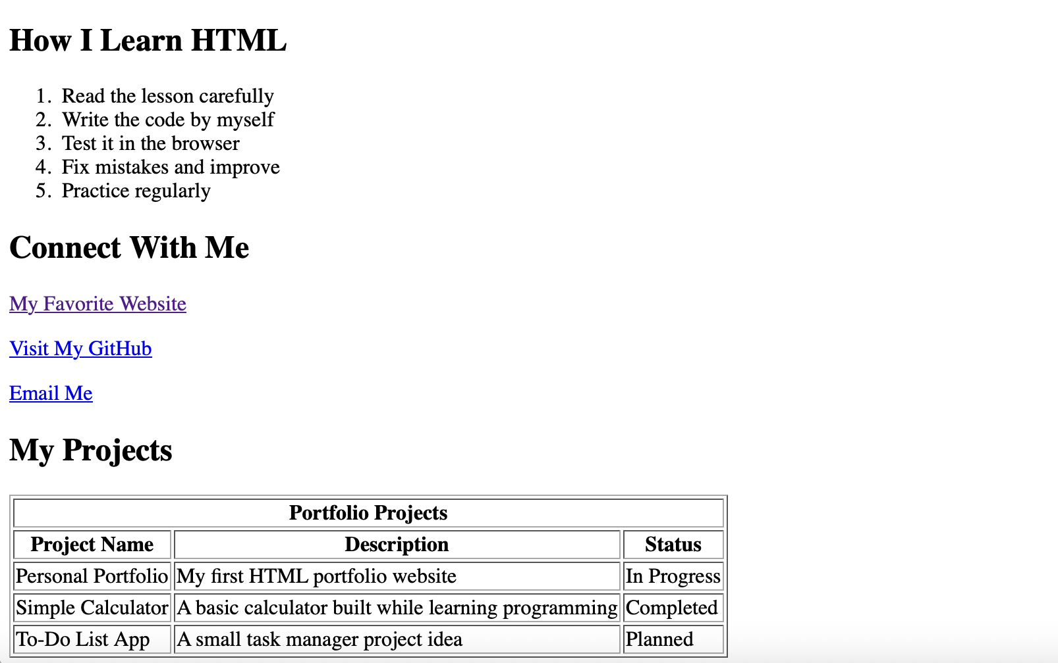
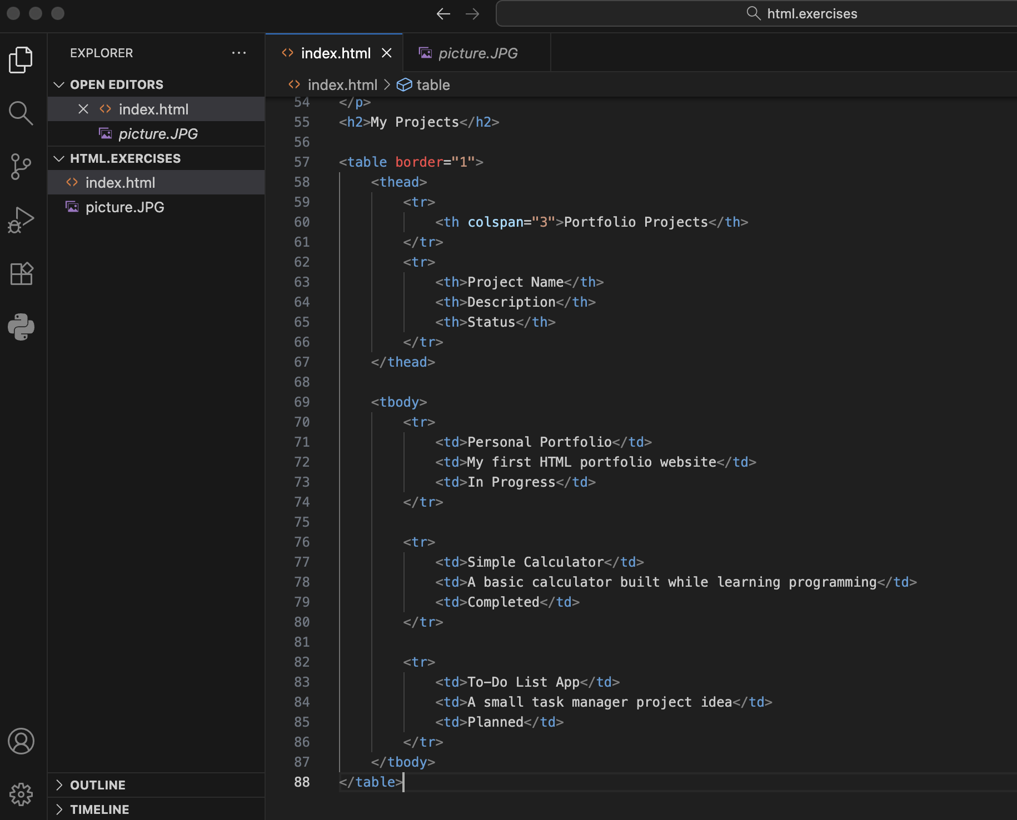

Exercise 2: Build a contact form in your portfolio
Add a contact section to your index.html: (1) Add an <h2> called 'Contact Me'. (2) Create a complete <form> with the following fields, each with a proper <label>: Full Name (text, required), Email (email, required), Subject (text), How did you find me? (select dropdown with at least 3 options), Message (textarea, at least 5 rows). (3) Add a submit button at the bottom. (4) Wrap each label + input pair in a <div> so they appear on separate lines. Save and test — try submitting without filling required fields and see what happens!

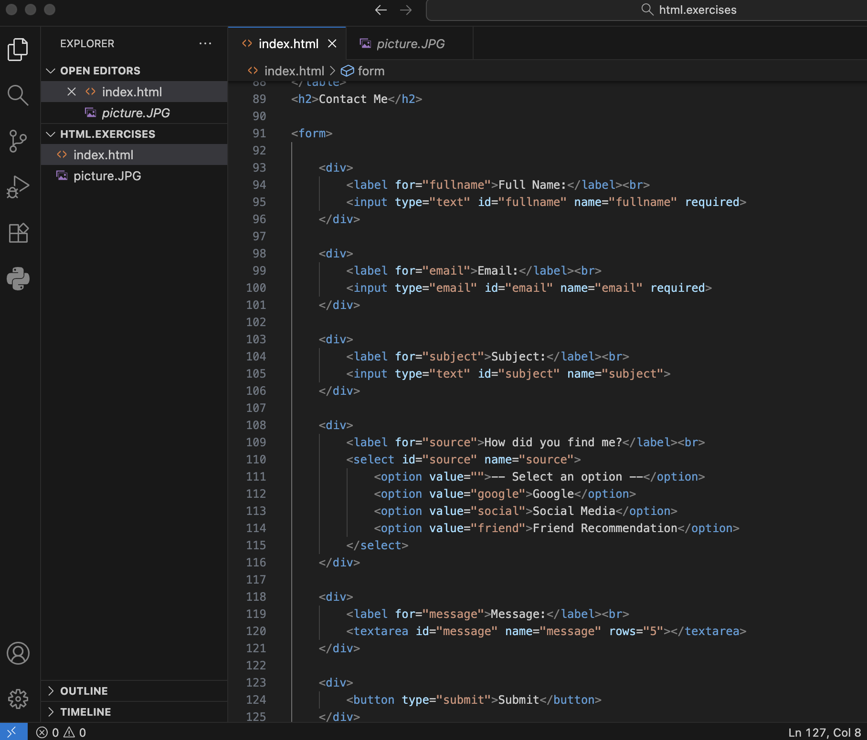

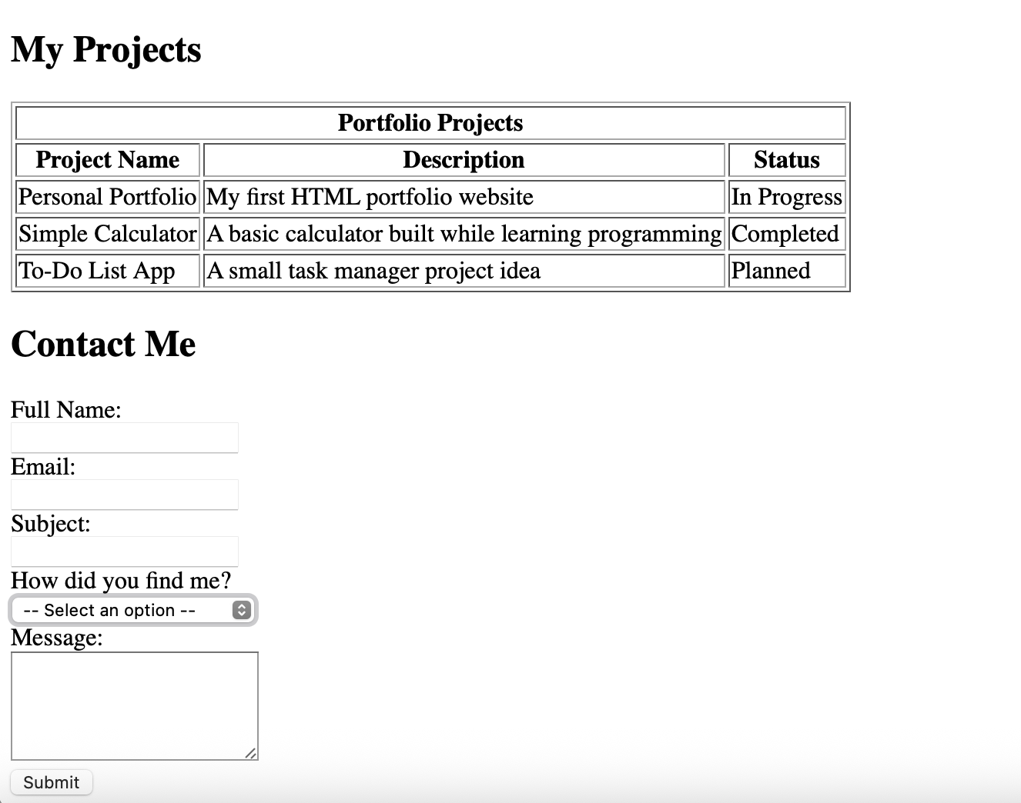

Exercise 3: Restructure your portfolio with semantic HTML
This is the biggest exercise of Week 3. Restructure your entire index.html using semantic tags: (1) Wrap your name and add a <nav> inside a <header> tag at the top with anchor links to each section. (2) Wrap all your main content in a <main> tag. (3) Wrap each section (About, Skills, Projects, Contact) in a <section> tag, each with a unique id. (4) Add a <footer> at the very bottom with a copyright line using &copy; for the © symbol. (5) Test your anchor navigation — clicking the nav links should scroll to each section!
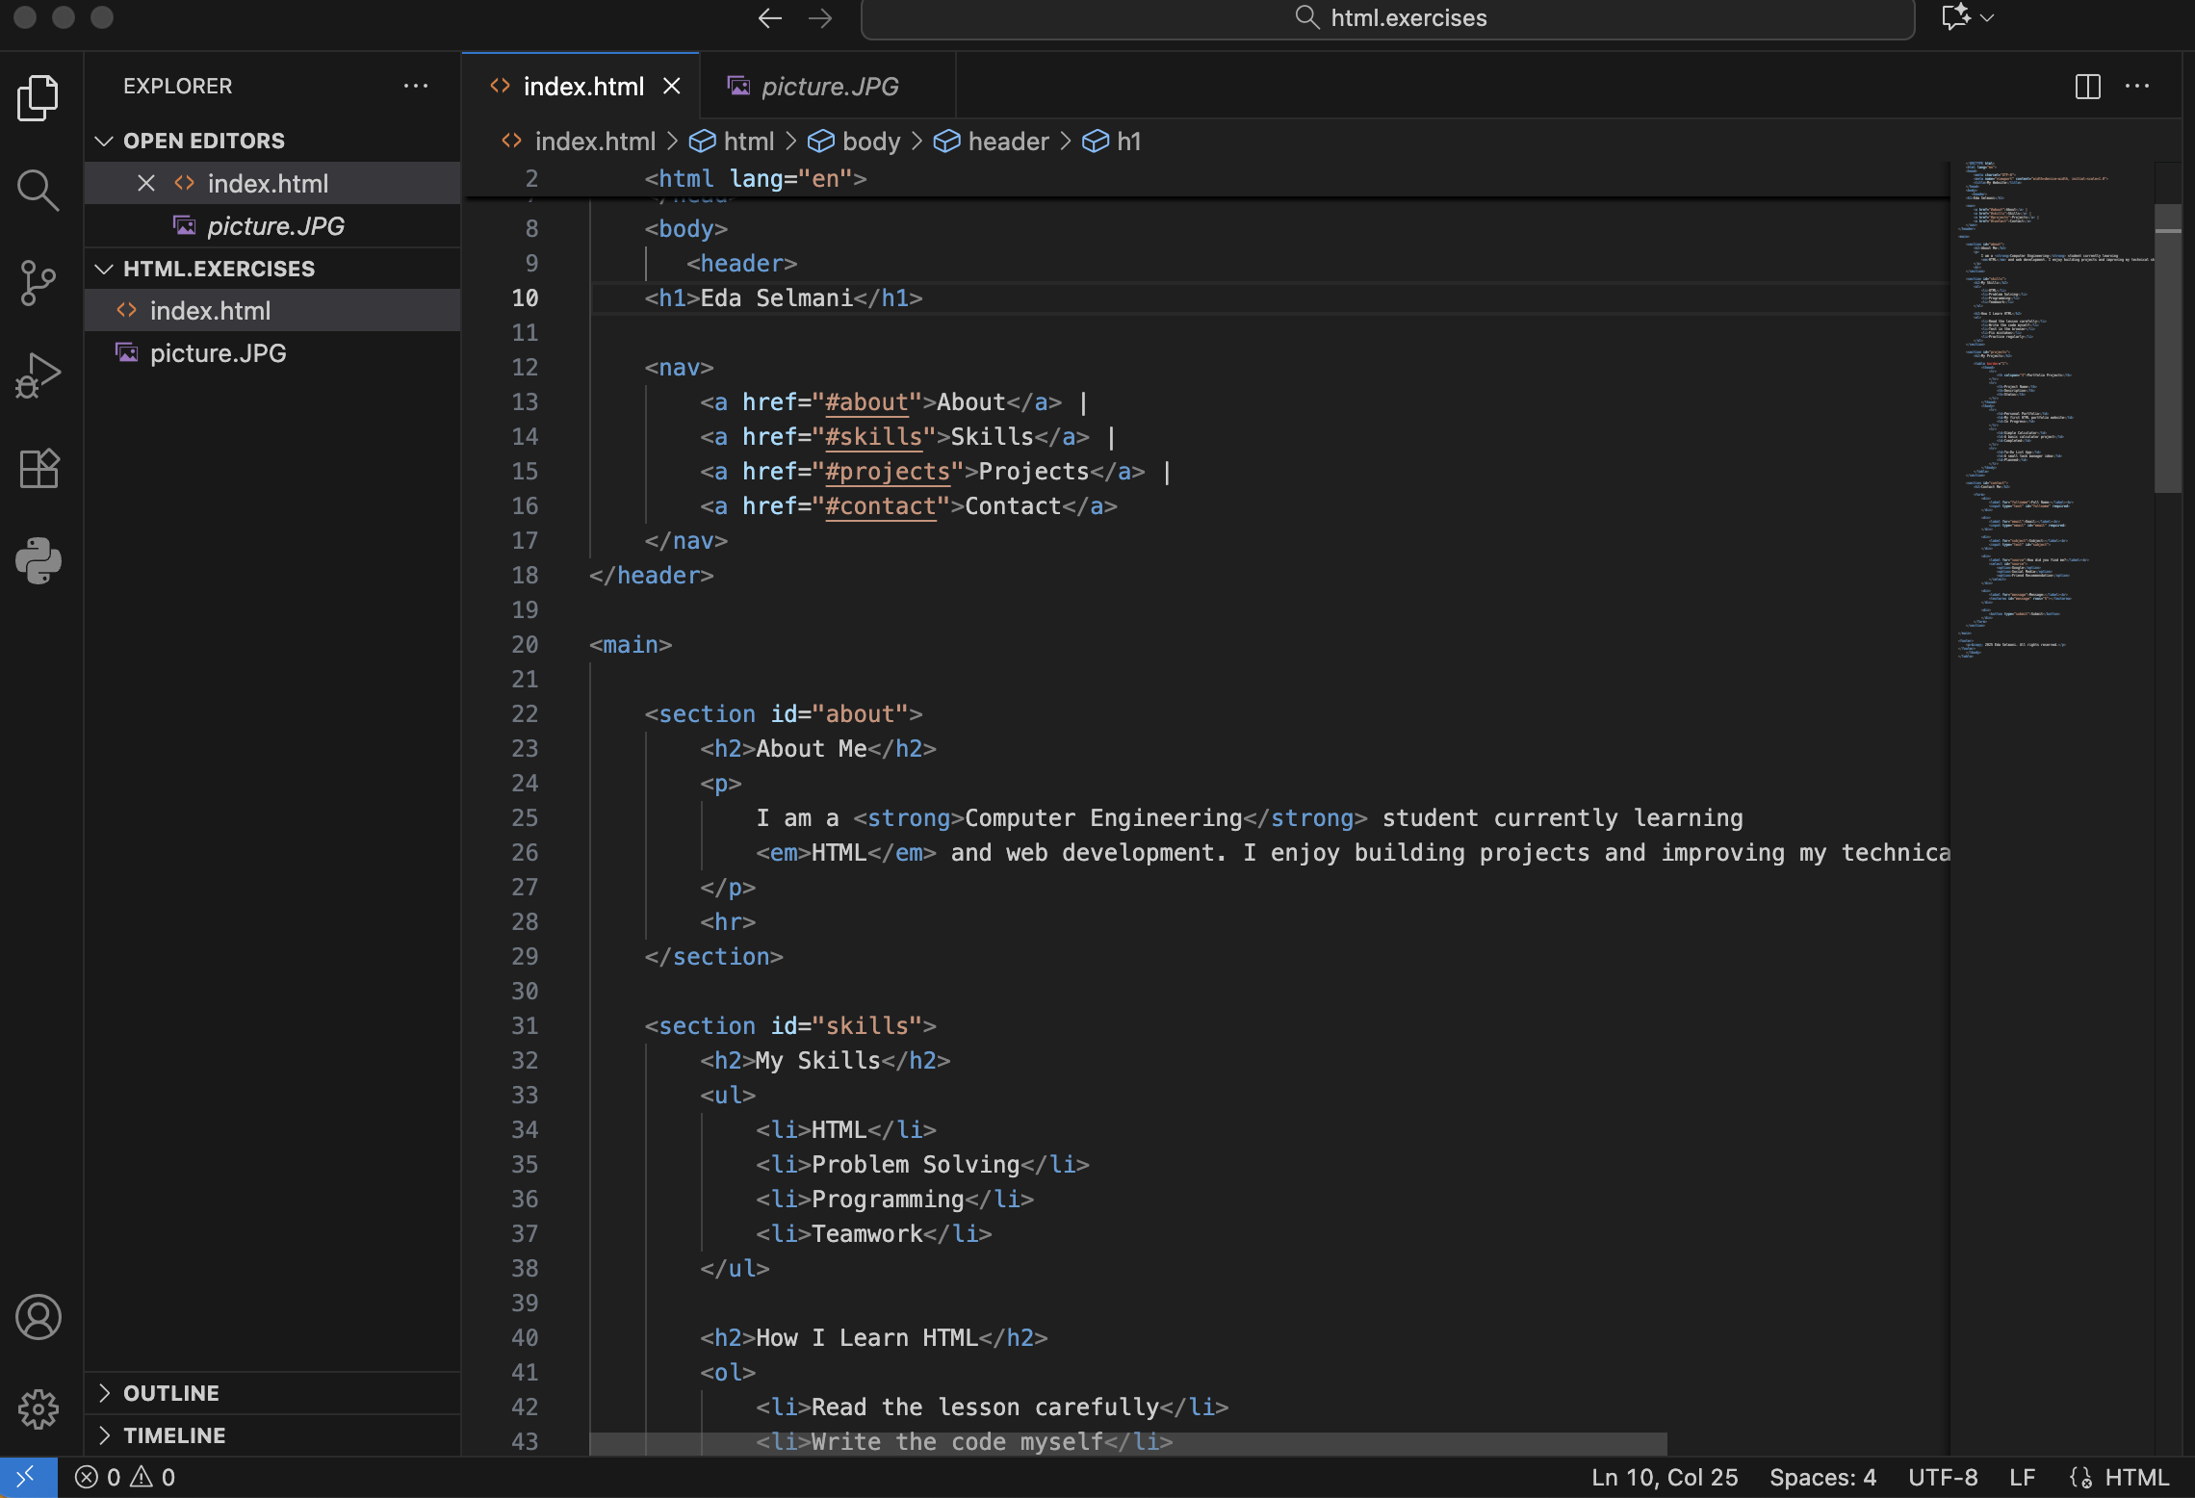
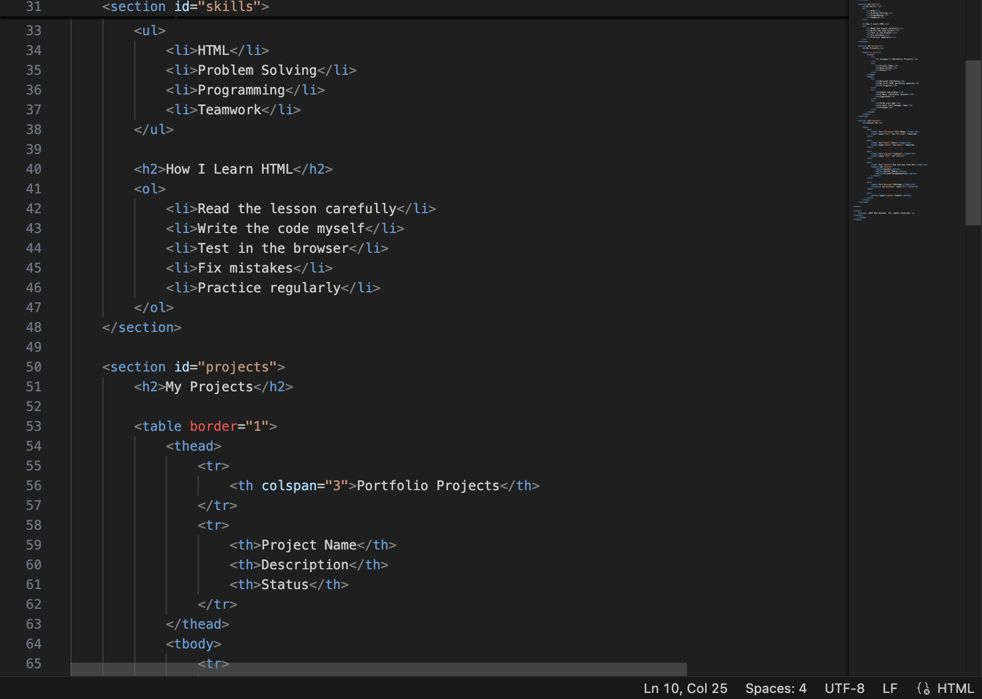

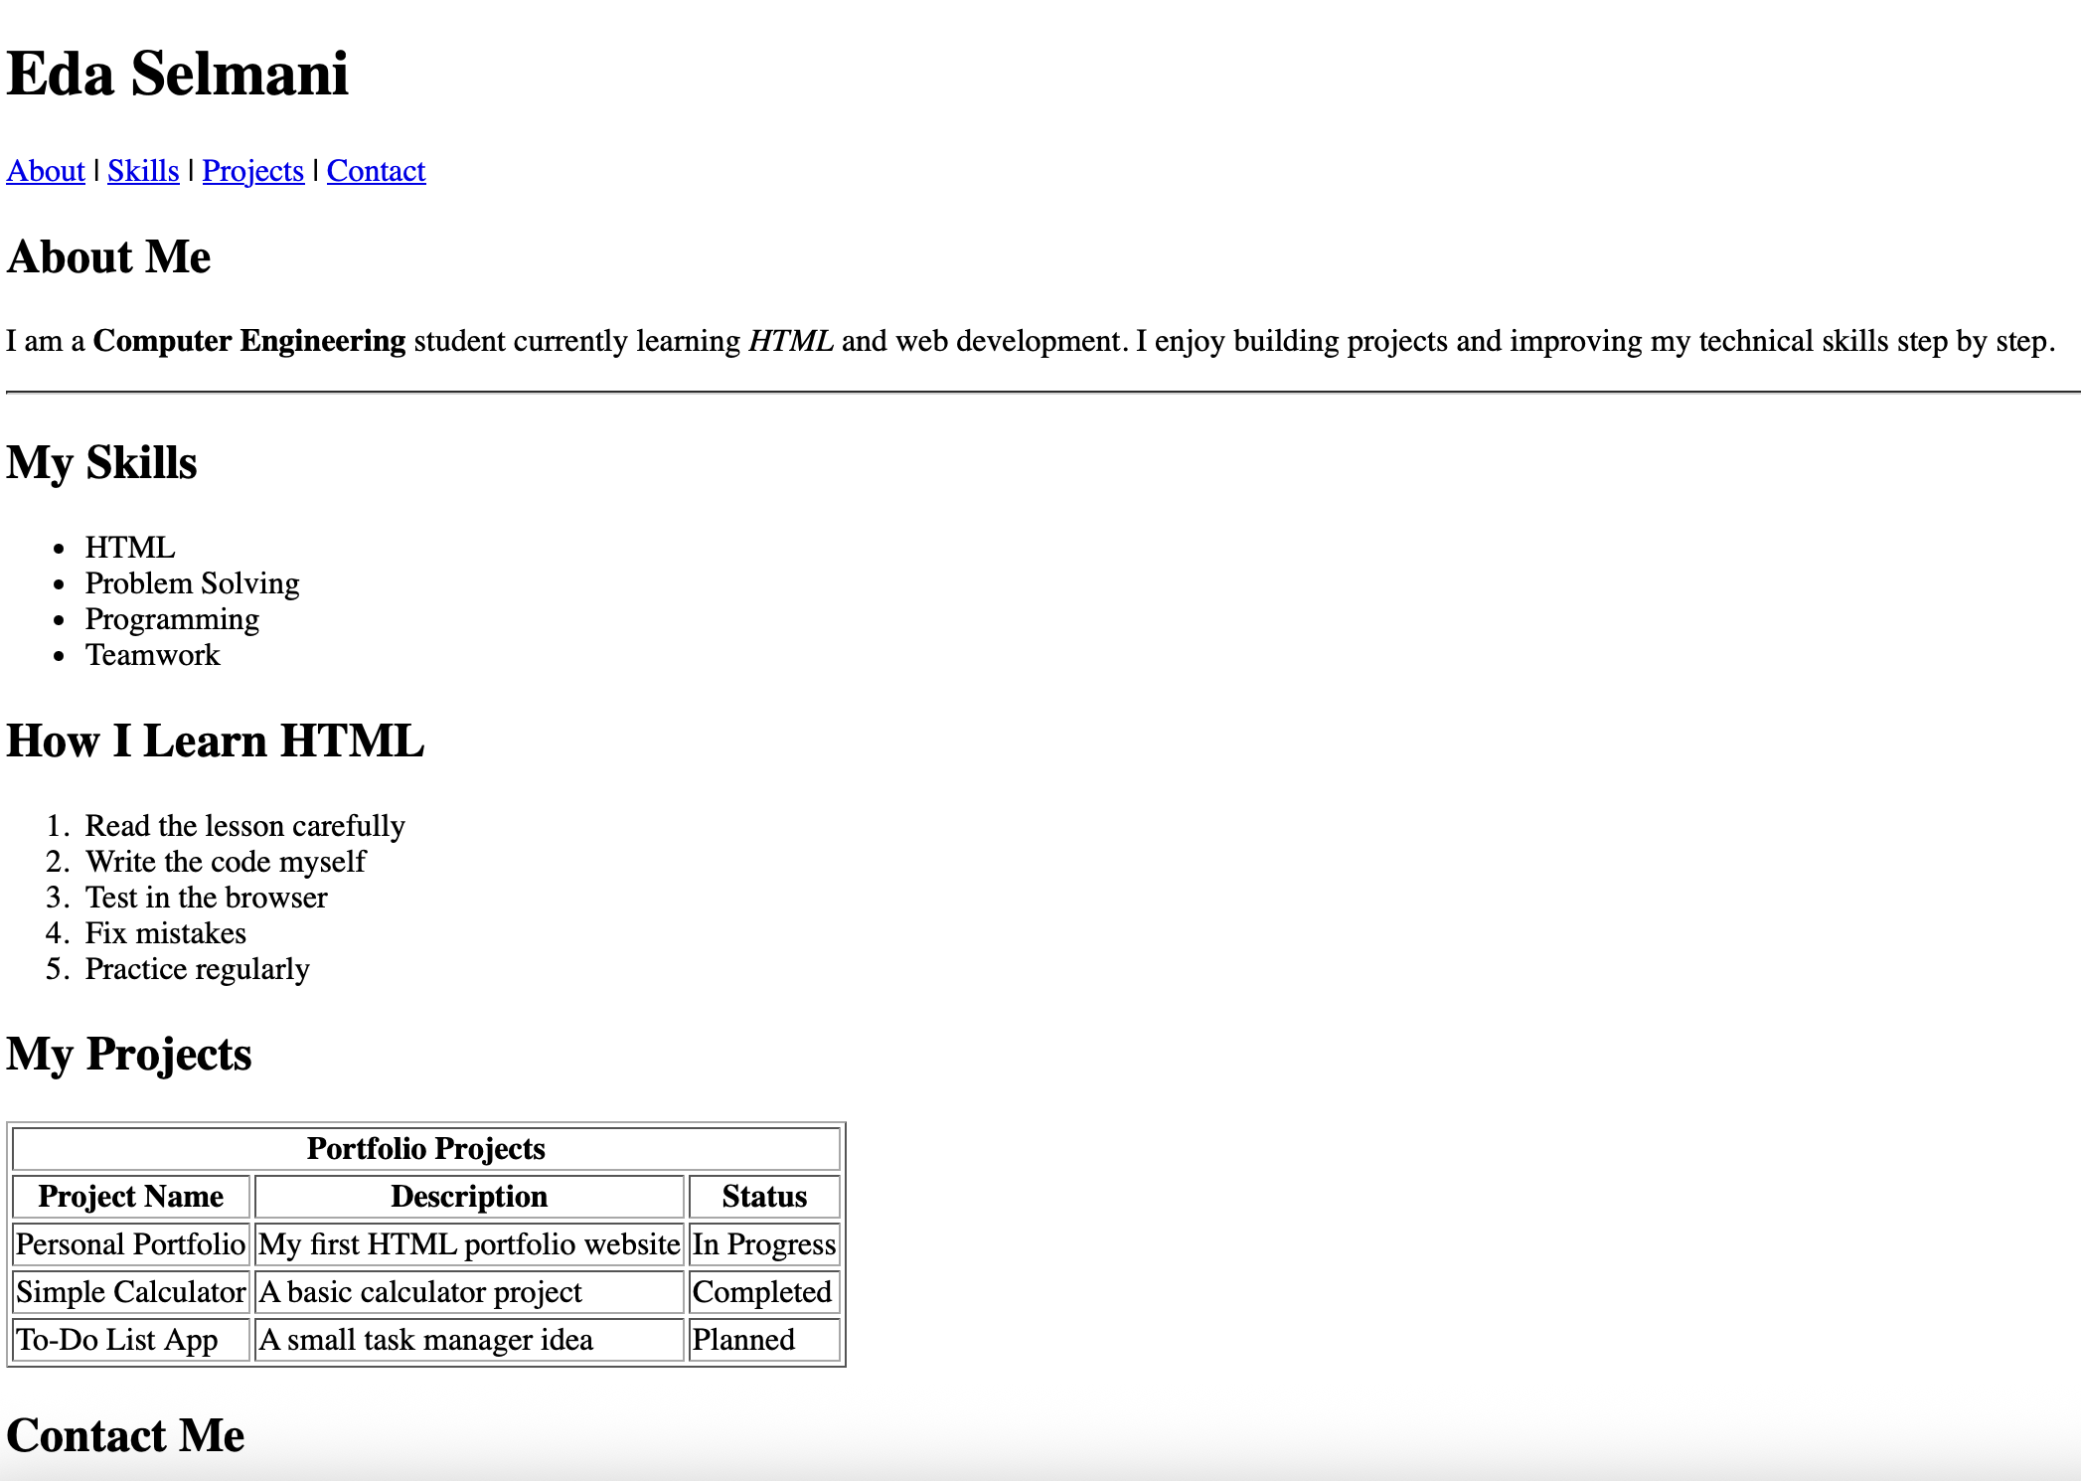
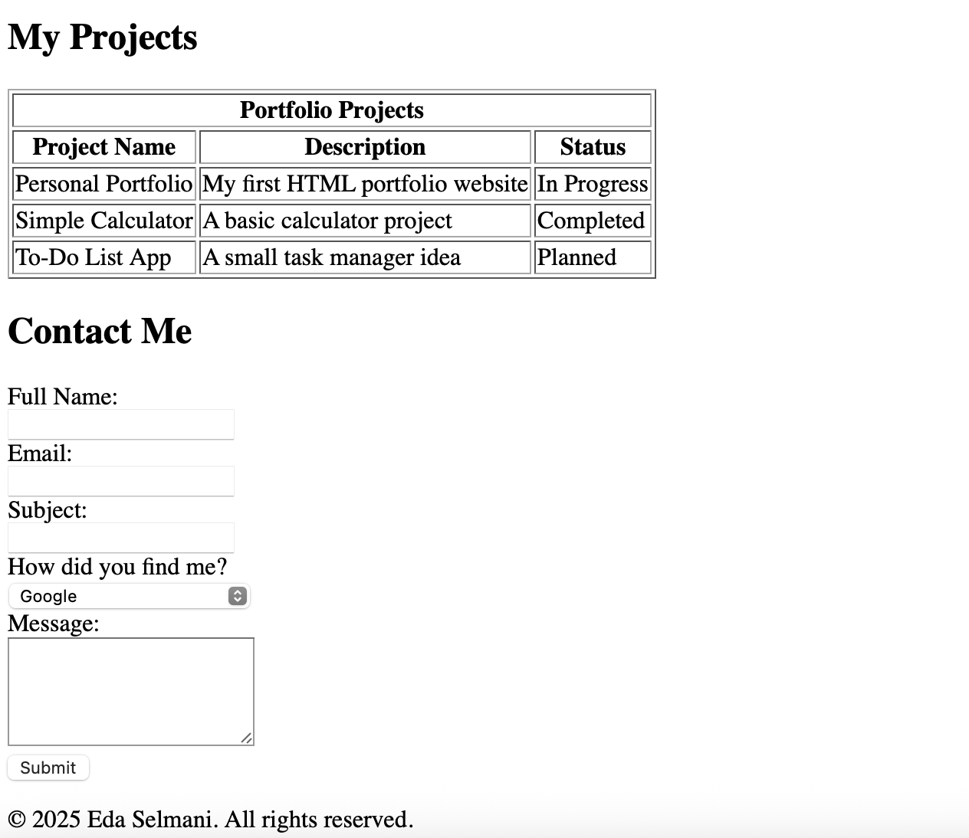

Exercise 4: Polish your portfolio’s head section
Open your index.html and update the <head> section: (1) Make sure you have the correct charset and viewport meta tags. (2) Add a meta description about your portfolio (write something real about yourself!). (3) Add a meta author tag with your name. (4) Update the <title> to include your name, e.g. 'Maria's Portfolio | Web Developer'. (5) In your footer, make sure you're using &copy; for the copyright symbol. Save and check the browser tab — it should now show your name!

